**DISABLED ATHLETES OF THE YEAR 2014**

**FEMALE**

Claire Ellis (AL2) - GBR

Claire has had another outstanding year, breaking world records at the Europe & Africa Championships in all 3 disciplines. In slalom, she broke the world record in the preliminary round with a score of 2.00/43/18.25 (surpassing the previous record by 3 buoys). She then went on to equal this record in the final. In tricks, she had a pending world record of 1980 that, upon review, was reduced to the still world record score of 1700 (an increase of 10 points over the previous record she set in 2012). In jump, she set a new world record of 9.5m (0.9m more than the record set in 2013). Claire won gold medals in all disciplines at the E&A Championships in the Women’s Standing Division, and in doing so also helped Great Britain to place 3rd contributing over 98% of the team points. In addition, Claire was the top ranked E&A skier in all disciplines for men and women combined over all categories of disability in 2014.

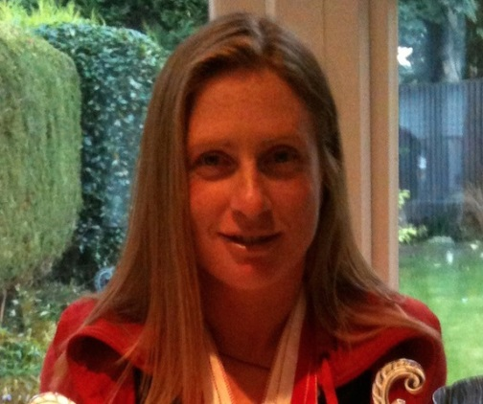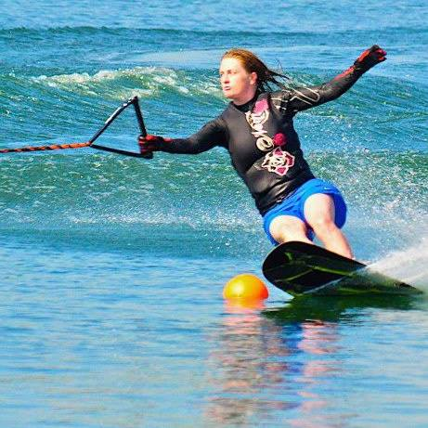

**MALE**

**Jorge Font (MP1) – MEX**

At the Disabled Nationals in Mexico, Jorge scored in two rounds 810 & 860 points in tricks, the highest score of which would result in 977 overall points versus the world record of 880 points which he holds and set at the 2013 World Championships. In two rounds of slalom, he skied 3@55/18.25m & 4@55/18.25m resulting in 928 overall points for the best round versus the world record of 2/58/18.25m, an excellent two event overall score of 1905.

