Cableski Male athlete of the year – 2013
Simon Herrmann – Germany

After 2012, when he was beaten in the World Cableski Championships, at the age of 28, Simon Herrmann proved that he is really the best Cableski Slalom skier we have at present. Simon already held the World Cableski Slalom Record, but this year he broke his own World Cableski Record by adding 3 more buoys into the 9.50m rope. The new World Cableski Slalom record is now set at 4 buoys at 9.50m rope.
At the E&A Cableski Slalom finals in Szczecinek Poland, Simon and World Champion Nadav Ativ from Israel, fought for the title. Nadav went first and ran 5 buoys at 9.75m, Simon had to do better and at both passes 9.75 and 9.50m rope, he was able to turn perfect on buoy one and two, making sure the cable worked with him. This allowed him to go as far as 4 buoys at 9.50m rope, while taking the E&A Cableski Slalom title and thus becoming E&A Cableski Slalom Champion.
With this score, Simon assured his first place in both World and E&A Cableski Rankingslists in Slalom. In addition to the E&A Cableski Slalom title, Simon also took the German Cableski Slalom title, something that is also an achievement, knowing that Germany is far the strongest country in Cableski Slalom.

In addition to his performances as an athlete, Simon is really working hard to make the sport grow. Working as an employee for a Cableski company, Rixen Seilbanen, Simon also lays on the basis for the “Master bro”, the new two-pylon cable that is being developed and will be able to allow to do slalom and jump on a cable, similar to skiing behind the boat. With Simon’s inputs and his experience of competitive Cableski this new system is being developed. The first installation was set up in 2013 and there will be a lot more to come in the near future.
As Simon has a lot of experience with Cableski installations, he is always ready to help out whenever at a competition there is a problem with the cableway. Having Simon at the site is like having ‘two in one person’, a top athlete present as well as a ready-to-help technician.

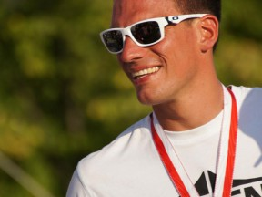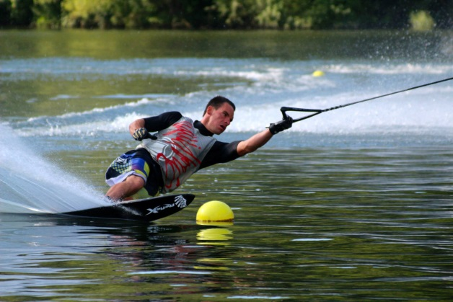

European Champion Slalom
New World record with 4 buoys at 9.50m rope!!!
First E&A Ranking List slalom
First World Ranking List slalom
Open Men German slalom Champion

